

***Reinvesting Locally***

**Whitepaper**

**v0.91**

**Authors**

Prof. Richard Werner – Oliver Studd – Borja Clavero

Audie Sheridan – Ben Senn – Theo Beutel – Roman Rogers

Contents

Disclaimer 3

Abstract 4

Problem Statement 6

Valhalla Network 7

Phase 1 7

Phase 2 9

Governance 9

Legal Structure and Controllers 10

Committees and Responsibilities 11

DAO Governance 13

Tokenomics 14

Early Funder Protection 14

Phase 1 Fundamentals 14

Phase 2 Fundamentals 17

Vesting 17

Use of Funds 18

Use of Private Raise 18

Use of Public Raise 19

Breakdown of Initial Costs 19

Roadmap 20

Team and Partners 21

Valhalla Foundation 21

Advisors 22

Partner Companies 22

The Financial System 23

The Importance of Small and Medium-Sized Enterprises (SMEs) – SMEs’ Economic Role 24

SMEs Depend on Banks 25

Large Banks Do Not Serve SMEs 29

Large Banks Lend for the Wrong Reasons 35

Concentrated Banking Speculates and Holds Less Capital 40

Summary of the Financial System 41

Bibliography 42

# Disclaimer

**NOTICE – January 2022, Valhalla Network Limited (hereafter Valhalla Network)**

**READ THIS NOTICE VERY CAREFULLY. CONSULT YOUR OWN LEGAL ADVICE BEFORE ENGAGING IN ANY ACTIVITY.**

NEITHER VALHALLA NETWORK NOR ANY THIRD-PARTY SERVICE PROVIDER SHALL BE LIABLE FOR ANY KIND OF DAMAGE OR LOSS, INCLUDING DIRECT AND INDIRECT, THAT MAY FALL UPON YOU AS A RESULT OF READING MATERIALS PRODUCED BY VALHALLA NETWORK’S FOUNDERS OR COUNSEL

**NO OFFERS OF SECURITIES, ADVICE OR SOLICITATION**

This information memorandum is intended for informational purposes only. It is not intended to be investment advice, solicitation of any kind nor an endorsement. Any decisions or actions taken on the basis of information presented in this published information memorandum or other content is done at your own risk and discretion.

**FORWARD-LOOKING STATEMENTS**

Certain information set forth in this information memorandum includes forward-looking information regarding the future of the project, future events and projections (referred herein as “statements”). These forward-looking statements are presented in the grammatically present form. Information contained in this information memorandum will constitute forward-looking statements and includes, but is not limited to:

i) the projected performance of the project;

ii) the projected performance of any of the separate legal entities;

iii) the expected development of the project;

iv) execution of the project's vision and strategy;

v) future liquidity, working capital, and capital requirements.

The forward-looking statements involve a variety of risks and uncertainties. Should any of these risks or uncertainties materialise, the actual performance and progress of Valhalla Network might differ from expectations set by the forward-looking statements. These statements are not guaranteeing future performance and no undue reliance should be placed on them. Valhalla Network undertakes no obligation to update forward-looking statements if circumstances change. By acting upon forward-looking information received from the information memorandum and other materials produced by Valhalla Network, you - the reader - bear full responsibility in the case of forward-looking statements not materialising.

**NO GUARANTEES**

There is no guarantee that the Valhalla Network group structure and model will be a success. Similarly, there is no absolute guarantee that the yield will be honoured. You are advised to thoroughly assess the risks and uncertainties involved before making any decisions. No promises in terms of return or future performance are made.

No promise of payment or profits are made to any future token holder. Any future securities owned by Valhalla Network will not be owned by token holders, and token holders have no rights or entitlement to dividends or any cash flow resulting from the securities owned by Valhalla Network, including any share held by Valhalla Network in the Phase 1 or Phase 2 banks.

**EXCLUSION OF LIABILITY**

Valhalla Network makes no representations or warranties whatsoever and disclaims all liability and responsibility to the maximum extent of the law for any statement or informative material communicated. The Valhalla Network team takes all reasonable steps to ensure the integrity and accuracy of information communicated.

**REPRESENTATION AND WARRANTIES FOR THE READER**

Upon taking action on the basis of information presented in this information memorandum or within other content produced by Valhalla Network, you confirm that:

a) the information memorandum or any other material produced by Valhalla Network is not an offering, solicitation or prospectus of any kind,

b) Valhalla Network is exempted from any direct or indirect liability to the maximum extent of the law,

c) you have a good understanding of the key components of Valhalla Network and understand how the DAO will operate,

d) you are aware of risks in the Phase 1 & Phase 2 banks’ bond industry and with SME loans and are able to bear potential losses in full.

**AS A PRIVATE TOKEN OFFERING, THE READER OF THIS DOCUMENT HAS PRE-CONFIRMED TO VALHALLA NETWORK THAT THEY ARE OVER 18 YEARS OF AGE AND ARE OF SOUND MIND.**

The content found in this information memorandum is provided “as is” for informational purposes only. It does not constitute financial advice and should not be taken as such.

You understand that you are solely responsible for reviewing any offering and performing such due diligence as you may deem appropriate, including consulting your own legal and tax advisers, and that any information provided by Valhalla Network shall not form the primary basis of your investment decision.

This material is based upon information Valhalla Network believes is reliable. However, Valhalla Network does not represent that it is accurate, complete, and/or up-to-date and, if applicable, time indicated. Valhalla Network does not accept any responsibility to update any opinion, analyses or other information contained in the material.

This material is for your general information only and is not an offer or solicitation to invest into Valhalla Network.

Past Performance is No Guarantee of Future Results.

Valhalla Network Securities Disclosures:

Valhalla Network Foundation will own shares in the Phase 1 and Phase 2 banks. These shares can be speculative and may involve a high degree of risk, above and beyond those associated with other asset classes or corporate lending. Investors should consider Valhalla Network Banks as a supplement to an overall investment strategy.

The contents of this document and the information incorporated herein by reference does not constitute a prospectus in accordance with the Prospectus Rules of the Financial Conduct Authority (the ‘‘FCA’’) made under Section 73A of the Financial Services and Markets Act 2000 and should not be construed as legal, business or tax advice. Each prospective investor should consult a legal adviser, financial adviser authorised under JFSC or tax adviser for advice if they have any concerns or questions about the contents of this document or the purchase of future governance tokens before making their decision to invest.

Neither Valhalla Network nor any of its respective Directors, Trustees, employees or representatives is making any representation to any offeree or purchaser or acquirer regarding the legality of an investment by such offeree or purchaser or acquirer under the laws applicable to such offeree or purchaser or acquirer.

# Abstract

*“We can decentralise power in our monetary system by abandoning the big banks and instead creating and supporting local not-for-profit community banks ...”*

Richard A. Werner, 2017

Banks and blockchain do not *need* to stand against each other. They often currently do, and this is because banks are viewed as centralised aggregations of power and an enemy of DeFi. Blockchain aspires to be the opposite. That drives the ethos of web3 - to decentralise and to do public good. Valhalla Network brings that ethos to banking.

Most people’s understanding of banks probably makes the idea of a not-for-profit bank seem impossible. This is the beauty of community banks, which, although becoming rarer, do still exist. This type of bank has a long and remarkable track record having been tried and tested in the three countries with the largest number of banks on Earth: the USA, Germany, and China. Community banks are so robust and important for the economy that they rarely go bust. Also, they are much more accountable than international banks - not one community bank in Germany required bailing out by taxpayers during the 2008 financial crisis!

How are these banks different? They focus on the community they serve over profits. They are still profitable - being not *for* profit is different than *non-profit –* they just profit differently*.* Instead of maximizing fees, avoiding taxes, and trying hard to extract money from customers, community not-for-profit banks lend ethically and work hand-in-hand with small businesses. This results in greater business competitiveness and greater general prosperity. Small businesses, all together, are the biggest employer in most countries and are the backbone of any economy. They need banks to serve their needs!

Valhalla Network’s mission is to build a network of community not-for-profit banks governed by a decentralized autonomous organization (DAO). The DAO will be a majority stakeholder in those community banks and use the profit from all the banks to launch more community banks. The remaining shares not owned by the DAO will be split between incentives for bank staff and charitable foundations that use profits to fund local, social, and charitable initiatives. Reinvesting a portion of profits back into the local economy amplifies the benefit.

Due to the capital requirements of starting a bank, before Valhalla Network starts any community bank, we need to build a capital engine that can help fund the creation of more banks and reward the DAO community. We need a way to ensure value for the token holders quickly and a way to fund the creation of the network of community banks. Valhalla Network will fill this need with a single for-profit bank whose target customers are sovereign entities. The great thing about for-profit banks is they are enormously profitable, and once the for-profit bank obtains its banking licence, the capital needed to fund more banks will be more readily available.

A banking licence takes time, and the funds received from early token holders will fund three things: the balance sheet of the bank (~80%), building the bank, and obtaining the banking licence (both ~20%). The funding must be in place to apply for the licence, and to get the licence you must build the bank. The funding is legally protected and placed in an escrow account. It’s released only under the condition that Valhalla Network is ready to obtain a bank licence. In the unlikely event that doesn’t happen, that 80% is returned to funders.

Since the banking licence will likely take between 18 months to two years to obtain, token holders should expect to hold their tokens for some time, but this longer-term strategy pays off with controlling interest in a bank. The DAO will decide what to do with the profits after the bank starts operations, including funding the mission. The *minimum* value of the token will be high because its value can be derived from real-world cash flows generated by the bank.

Why this mission? Why do this with a bank? Because modern banking is broken. The incentives are all wrong. Banks should exist to serve the communities in which they reside, but big banks simply don’t. They should provide credit to small and medium enterprises, but as they get bigger, they stop doing that. What banks do with their money matters, especially with the size of modern banks. Where they put their money moves national economies. Neither banks nor the national central banks that control the money supply take their responsibility for the economy’s health seriously. Their incentives twist their mission.

Valhalla Network sees a better path.

# Problem Statement

Our financial system functions to serve the people and facilitate economic growth and development. Textbook economics says that banks play a modest role and their actions should not dominate or significantly shape the economy. However, empirical research (Werner, 2014a, b, 2015) shows such theories are wrong. Banks play a *pivotal* role in the economy. Their decisions about who to lend to and for what purpose reshapes the economic landscape within a short time period. This means the type and structure of the banking system significantly impacts how economies develop and perform. Economies with concentrated banking systems tend to produce uneven economic development with boom-bust cycles and increasing inequality. Decentralised banking systems consisting of many small local banks, as in Germany, tend to have thriving communities, high job creation, low unemployment, lower inequality and resilience to external shocks, as well as fewer financial and economic crises.

Despite the above, there is increasing global pressure on banking systems to consolidate, mainly due to policies orchestrated by central planners at central banks. They manipulate financial markets to suppress interest rates towards zero or even negative rates, while significantly increasing costs in banking by disproportionate increases in regulatory burdens, especially for smaller institutions. The regulatory burden and low interest rates are an attack on small banks and small businesses, and they create conditions where margins cannot support lending to small and medium enterprises (SMEs) at lower rates. Studies show that bank profitability is positively correlated to the level of interest rates and the slope of the yield curve (higher yields at longer maturities) (see Borio, Gambacorta and Hofmann, 2015).

At the same time, the central banks are on route to *compete directly against banks*, even though as bank regulators they should not step into the arena. Much like a soccer referee deciding to run with the ball in order to score a goal, while using his power of issuing yellow and red cards to send any opponent off the football pitch.

This direct competition by the regulators against those they regulate is hidden behind the misleading label of central bank digital currencies (“CBDCs”). These CBDCs would be better understood if plainly referred to as what they are: retail deposit accounts at central banks.

Further concentration of banking systems, which would follow after the introduction of such direct retail accounts by central banks, would concentrate the decision-making power over key economic issues in the hands of ever fewer people.

Yet *highly concentrated banking systems have historically underperformed compared to decentralised banking systems*. The ultimate illustration of this principle is the experience of the Soviet Union, which only had one bank – the central bank. China under Deng Xiao Ping abandoned Soviet-style monobanking and instead Deng oversaw the creation of thousands of new banks in the years since 1978. Chinese economic performance improved dramatically, delivering four decades of double-digit economic growth, lifting more people out of poverty than at any time before in history.

In contrast to the nearly absolute unaccountability of large centralized banks, a decentralised system of community banks ensures true accountability for the important decisions taken by the banking system. In practice, only small local banks can be made accountable to the public. Too-big-to-fail banks effectively cannot be sufficiently sanctioned by regulators to ensure sustainable bank behaviour, and they often end up rewarded for their bad behavior.

# Valhalla Network

Valhalla Network wants to bring the power of decentralization to banking by building a growing system of community banks governed by a decentralised autonomous organisation (DAO). The DAO will establish and own a global network of not-for-profit community banks. These community banks will serve as centers for sustainable economic growth by focusing on lending to local small & medium sized enterprises in an ethical manner. Each community bank will be owned 75% by Valhalla Network and the remaining 25% split between a charity foundation and bank staff incentives. This means each bank will allocate a significant portion of their dividends to a charity that reinvests into local, social, and community initiatives as per the DAO’s ESG (environmental, social, and governance) policy.

Valhalla Network has this set of aims:

* To enhance credit availability to small and medium sized businesses;
* To decentralise the banking system through small locally focused banks;
* To support communities and businesses,
* To increase the quality of financial education;
* To launch charity foundations to fund and support local social initiatives; and,
* To democratise finance and the people’s access to attractive central bank credit lines.

To meet these aims, Valhalla Network will execute two phases:

## Phase 1

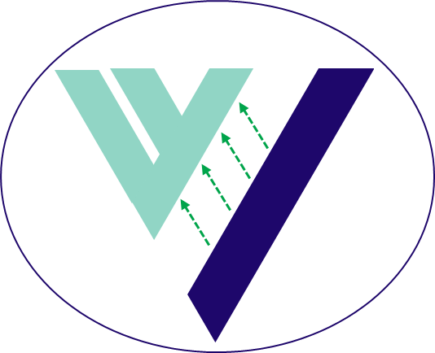The establishment of a specialised *for*-profit bank. The bank will combine higher returns with a highly conservative financial model, contrary to traditional banking models. It will immediately begin generating returns for Valhalla Network and will achieve an average return-on-equity (ROE) of almost 30%, significantly higher than market average.[1]

The fundamental aim of Phase 1 is to act as a base to support the DAO in its early life and help propel Valhalla Network into Phase 2, the establishment of community banks.

This strong real world cash flow translates into attractive ROIs for Valhalla Network, reaching a 10-year ROI of over 680%. We forecast the bank to begin operations 3-6 months after the token generation event (“TGE”).

The business model will be exposed to the most rigorous and challenging process by the regulators, who will explore all areas of the business model. The startup team will have to provide evidence through stress test models that the business model is strong enough that the bank will survive improbable difficult business conditions.[2] Essentially, the banking licence won’t be granted unless the bank is certain to be profitable and able to survive. The actual business model is therefore irrelevant.

The DAO will own *but not manage* a bank - each bank will have its own balance sheet and be managed individually by experienced senior bankers who will have been interviewed by the regulators.

Publishing the business model here would provide opportunities for frontrunning, and so the business model for the bank remains proprietary. The business model, as we will present it to the regulators, has forecasted metrics below:

|  |  |  |  |  |  |
| --- | --- | --- | --- | --- | --- |
|  | **TGE+1** | **TGE+2** | **TGE+3** | **TGE+5** | **TGE+10** |
| **Texas Ratio** | 4.24% | 4.19% | 4.45% | 5.21% | 5.94% |
| **Book Value / € M** | 79 | 213 | 373 | 645 | 995 |
| **Equity / € M** | 75 | 175 | 275 | 375 | 375 |
| **Dividends paid to the DAO[3]** | 1 | 11 | 30 | 108 | 305 |

The Texas Ratio assesses a bank’s financial position by taking a ratio of non-performing assets by the sum of the bank’s tangible common equity and loan loss reserves. A ratio above 100 means the bank may need to cover potential losses; a low Texas ratio means the bank has sufficient resources to cover potential losses.

The total value of the DAO will be a combination of the underlying cash flows, any premium from the distributed ledger ecosystem, the intrinsic value of bank licences, and the large amount of public good.

Despite the strong returns generated by the Phase 1 bank, it is worth noting the financial model is highly conservative with built in buffers and higher than forecast loan provisions. Examples of the conservative nature of the Phase 1 financial model include:

* Cost of funding is set considerably higher than we can achieve;
* Return on assets is set significantly lower than actually achievable;
* Start-up costs are budgeted higher than necessary;
* Across the portfolio, probability of default and loss given default (LGD) are set higher than risk ratings suggest;

The banking sector is one of the most regulated industries, with regulators spending large amounts of capital and time on managing a bank’s risk. The regulators set several ratios the bank must meet (such as liquidity coverage ratio, leverage ratio, CET1 ratio, and others), the financial model used not only meets the ratios but far exceeds them. Lastly, banks have buffers in place (such as the countercyclical capital buffer and the capital conservation buffer) to further reduce risk.

During this phase, the for-profit bank will obtain its licence, begin operations, and start accumulating capital to support the mission and reward early token holders.

## Phase 2

We forecast Phase 2 to begin TGE+1, after the Phase 1 bank is fully operational. Valhalla Network will build a network of community banks across the world, starting in Europe and targeting specific countries and communities with the most need. Over time, we aim for the network to expand to Asia, America, and Africa as resources increase (depending, of course, on the preferences and voting of governance token holders). It is our hope the community will actively engage with the DAO to help establish each community bank by completing a range of feasibility reports and market demand surveys, for which community members will be compensated for their time and work.

Every single community bank will support SMEs and provide a true local alternative to the big banks. The Phase 2 banking model will combine stable growing returns with an ethical and highly conservative financial model. Although not as profit generating as the Phase 1 bank and acting in a not-for-profit manner, the community banks will still generate sustainable returns with an avg. 10Y ROE of 20% and a projected 10Y ROI for Valhalla Network of c. 180%.

The community banks will revitalize the local economy by acting as a center of sustainable growth. A portion of all profits will go towards a charity foundation which will fund & support local community initiatives, while the community bank, supported by Valhalla Network, will engage with local schools to provide financial education to teens and young adults.

**The Community Banking Mission Statement**

The community banking missions statement is to become the preferred banking partner for local SMEs by:

* Introducing competition to the concentrated banking sector;
* Enhancing credit availability;
* Creating tailored banking services for small businesses; and,
* Offering truly attractive savings packages for depositors.

Furthermore, by fostering strong relationships throughout the community and local businesses, each Community Bank will generate healthy sustainable returns for the DAO and be able to reinvest in local community initiatives through the Community Bank Foundation.

# Governance

Valhalla Network will adopt and maintain a robust governance structure to facilitate effective and prudent management to deliver long-term success of the network. Valhalla’s governance framework delivers transparency and trust for all stakeholders and provides individual accountability necessary to foster long-term financial stability, therefore supporting token holders and wider economies.

The DAO will govern the network of banks it owns, the creation of additional banks, the facilitation of the mission, and the charitable public goods done. Ownership of the banks within the network establishes some level of control, and the DAO will govern that control, but the DAO will not manage the banks or act as bankers. Banking is among the most highly regulated industries, and for this reason the banks will be run by qualified bank managers chosen by the DAO and interviewed by the respective regulator. Lastly, the DAO will govern what to do with the profits the banks return to Valhalla Network.

The Valhalla Network Foundation will be the legal entity that executes the will of the DAO. In order to act as owners of banks, sign contracts and other legal necessities of real-world operations, the DAO will need to create and maintain a holding company. This section describes the multi-layered governance framework adopted by Valhalla, the roles and responsibilities of senior contributors, committees, and the signatories.

## Legal Structure and Controllers

Valhalla Network Foundation will be incorporated in Switzerland. Valhalla Network Foundation will be the majority owner of the holding company (which owns 100% shares of the respective bank). The Phase 1 bank will be incorporated in the Grand Duchy of Luxembourg, with the bank holding company incorporated in the Principality of Liechtenstein, and the Phase 2 banks will be incorporated throughout Europe and the rest of the world. The figures below give a high-level description of the group and ownership structure of the Phase 1 and Phase 2 banks, respectively.

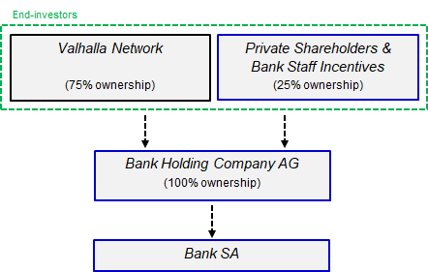Phase 1 bank legal structure:

Phase 2 bank legal structure:

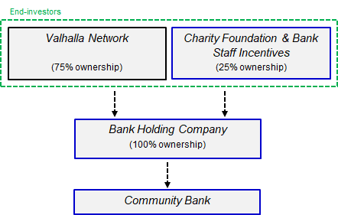

## Committees and Responsibilities

Valhalla Network will establish a set of committees to oversee different areas of the protocol and provide more robust governance and transparency for all stakeholders.

The committee structure is depicted in the diagram below, followed by a brief overview:

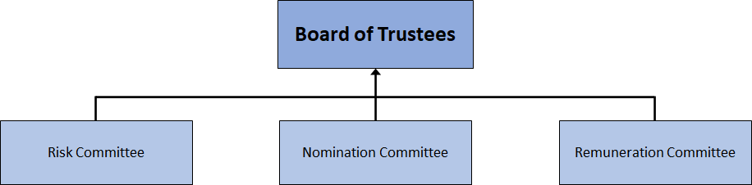

|  |  |  |  |
| --- | --- | --- | --- |
| **Committee** | **Key Responsibilities** | **Frequency** | **Members** |
| Risk, Audit, and Compliance | - Oversee the development and implementation of the protocol’s risk management measures in relation to any technical, legal, governance, financial, or emerging regulatory risks  - Ensure adherence to the protocol’s internal governance framework and fulfilling accepted token holders’ proposals  - Review the adequacy of existing risk resources & measures to ensure suitability and robustness  - Authorise internal and external audits, and any other penetration or vulnerability testing  - Review results of any audit or test and address any outstanding concerns  - Monitor the integrity of the annual accounts of the Foundation, and sign them off in accordance to Swiss law  - Ensure the Foundation adheres to all relevant regulations and laws | The committee shall meet at least four times a year at appropriate intervals and otherwise as required | Chair: CEO  Members: CFO, CTO, Head of Strategy, and Mark Jolly |
| Nomination | - Review the structure, size, and composition required of the Foundation  - Identify and approve suitable contributors, advisors or signatories | The committee shall meet at least four times a year at appropriate intervals and otherwise as required | Chair: CEO  Members: CTO, Head of Strategy, Lead Tech Contributor |
| Remuneration | - Determination of the terms and conditions of employment with the Foundation | The committee shall meet at least two times a year at appropriate intervals and otherwise as required | Chair: Project Chair  Members: CEO, Matt Gubba, Martin Phillips |

The below management responsibilities map sets out the Foundation’s management and governance arrangements.

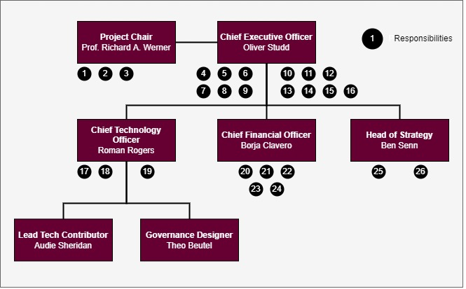

Each senior contributor has individual responsibilities to aid transparency and accountability to Valhalla Network’s community, these are defined as follows:

1. Responsible for overseeing the development of the protocol;
2. Responsible for overseeing the establishment of Phase 1 and Phase 2 banks;
3. Responsible for chairing and overseeing the performance of the Remuneration Committee;
4. Responsible for sharing the mission and vision with all stakeholders;
5. Responsible for the allocation and attestation of all responsibilities;
6. Responsible for ensuring the token holders are properly and fairly represented at Board level;
7. Responsible for ensuring the token holders’ proposals are executed in line with the Governance policy;
8. Responsible for the development and deployment of a robust Board and Committee Structure;
9. Responsible for ensuring that policies and practices within the governance framework are embedded and followed by contributors;
10. Responsible for the ultimate success and timely execution of all project roadmaps;
11. Responsible for ensuring potential and actual Conflicts of Interest are identified, declared, and managed appropriately;
12. Responsible for the security of vested tokens;
13. Responsible for Treasury security and signatories;
14. Responsible for ensuring all contributors act in good faith and in the best interests of the token holders;
15. Responsible for chairing and overseeing the performance of the Nomination Committee;
16. Responsible for chairing and overseeing the performance of the Risk, Audit, and Compliance Committee;
17. Responsible for the timely execution of all technology roadmaps;
18. Responsible for the design, deployment, and maintenance of technical security controls;
19. Responsible for proposing and organising independent technical audits in line with the Risk, Audit, and Compliance Committee;
20. Responsible for the design and maintenance of financial controls;
21. Responsible for ensuring sufficient liquidity;
22. Responsible for ensuring accurate and timely financial reporting to token holders;
23. Responsible for the preparation of the annual accounts;
24. Responsible for making available sufficient capital to meet regulatory requirements of banks within the network;
25. Responsible for the design of Valhalla Network’s strategy to:
    1. Increase the value of tokens for the benefit of the token holders
    2. Ensure longevity of the protocol
    3. Positively impact and improves the lives of people
26. Responsible for innovation and gradually transferring the banking network infrastructure onto a distributed ledger system.

## DAO Governance

The governance framework powering Valhalla Network will be rolled out over time in three stages, gradually decentralising.

During stage 1, Valhalla Network governance is through a Gnosis multi-signature wallet ("multisig"), which is a shared wallet requiring a certain number of co-signers to approve transactions. The Valhalla Network multisig will be governed by both members of the Foundation and independent advisors as signatories and will require 5 out of 7 to approve transactions. During stage 1, new signatories may be identified and recommended by the Nominations Committee to decentralise the approval process, with the ratio required to approve transactions remaining consistent to maintain a high level of security. This multisig will remain in place until the instantiation of the DAO, the distribution of governance tokens, and minimisation of common attack vectors. These attack vectors include outstanding technical audits of Valhalla Network's smart contracts and a sufficient distribution of the governance token. The specific requirements and timeline are subject to governance decisions taken in stage 2.

Stage 2 describes a temporary state to transition some governance from the multisig to the DAO. During this time, a facilitated process among early contributors to the Valhalla Network and strategic partners will map out all layers of the DAO's decision-making capabilities, the design of governance processes as well as the choice of tooling. This process includes various iterations of prototyping, both before and after the release of version 1.0 of the whitepaper. The output from stage 2 is one of several governance proposals, the first of which is put up to a vote immediately after Valhalla Network's governance token has launched.

With the inception of Valhalla Network and its governance token, the third stage introduces true DAO governance. The DAO will vote on the proposal(s) from stage 2 and the governance framework will iteratively improve. While the specifics are subject to the multi-stakeholder design process in stage 2, the governance framework in stage 3 should include:

* A multi-step governance process to voice ideas, discuss proposals, and make decisions, each in an appropriate, productive, inclusive and transparent manner. Furthermore, the community will be able to earn additional tokens by completing work on behalf of the DAO to help in the roll-out of Phase 2 (the establishment of community banks);
* On-chain representation of final decisions with a low-cost solution for community members to vote, e.g. through gasless voting (such as Snapshot) or through deploying the governance contracts on an EVM-compatible layer 2 or sidechain (such as Arbitrum, Polygon or Gnosis Chain, formerly xDAI); and,
* The option for token holders to delegate their voting power to a trusted expert who could represent a certain stakeholder group, region, or cause relating to one of Valhalla Network's goals.

With stage 3 being an open-ended process, Valhalla Network DAO appoints a governance committee to continuously oversee its governance processes to serve the needs of its stakeholders and suggest improvements to the DAO. Initially, the multisig will remain in place to keep the treasury secure, mint tokens on behalf of the DAO, and release parts of the treasury management to the DAO. Over time, the DAO will become the sole manager of the treasury.

# Tokenomics

There will be a single circulating model with one category of token in circulation. These utility tokens for governance will be generated at the TGE and issued first to help build the balance sheet of the Phase 1 bank.

For Phase 2, new governance tokens will be minted and issued to support and establish a network of small business lending focused community banks. The total possible number of governance tokens ever to be minted will remain capped at 4 billion.

## Early Funder Protection

Over 80% of funds raised during the pre-sale and private sale will be secured in an escrow account at a fully regulated escrow service provider. These funds will remain secured & locked during both the token generation event & the setup phase, with stringent rules in place to ensure the team successfully meets the unlock conditions before the Valhalla Network Foundation can receive the funds. The purpose of the escrow account is to entrust an independent party with the safekeeping of funds until the escrow parties fulfill the obligations of the escrow account.

Before the funds can be unlocked, the Foundation must receive a letter of support from an independent financial services regulatory consultancy firm for the Foundation having a strong chance of obtaining a banking licence. The funds must be unlocked before the Foundation can conduct a public sale. In the unlikely event the Foundation fails to meet the unlock criteria, the funds will remain locked & returned to the pre-sale & private sale investors, and all tokens purchased will be burned.

## Phase 1 Fundamentals

The 80% of capital secured in the escrow account will be reserved in its entirety as common equity tier 1 (CET1) for the Phase 1 bank. The remaining funds, outside of the escrow, will be used to build the protocol and prepare the bank for operations.

Setup and launch of the for-profit bank will take approximately 18-24 months from date of private sale; this includes setting up the Foundation and banking entity, executing the technical solution, and the application and authorisation of a banking licence. Governance tokens will confer voting rights to holders, enabling them to submit and vote on proposals.

Staking will commence upon token generation with an interest rate of 5%, the treasury will replenish staked tokens through open market operations and token buybacks by the token entity company. Staking rewards will be paid entirely in governance tokens. As Phase 2 commences, staking rewards will increase to an interest rate of 12.5% per annum.

In total, only 4 billion governance tokens can ever be minted. The chart below provides a breakdown of total governance tokens:

The future primary function of the unallocated treasury tokens will be to support capital raises, with secondary functions including treasury management, airdrops, and contingency funds. The Team category includes all tokens held by both Foundation contributors and advisors. The volume and value of governance token sale rounds (excluding future capital raises for Phase 1 & Phase 2) are shown in the table below.

|  |  |  |  |  |
| --- | --- | --- | --- | --- |
| **Round** | **Round name** | **Volume of tokens sold** | **Price per token (€)** | **Value of tokens sold (€)** |
| 1 | Pre-sale | 7,500,000 | 0.080 | 600,000 |
| 2 | Private sale 1 | 50,000,000 | 0.100 | 5,000,000 |
| 3 | Private sale 2 | 50,000,000 | 0.100 | 5,000,000 |
| 4 | Private sale 3 | 50,000,000 | 0.100 | 5,000,000 |
| 5 | Private sale 4 | 50,000,000 | 0.100 | 5,000,000 |
| 6 | Public sale | 200,000,000 | 0.275 | 55,000,000 |
| 7 | Public overflow  (not targeted) | 200,000,000 | 0.275 | 55,000,000 |
| Total (excluding public overflow) | | 407,500,000 | - | 75,600,000 |

At the TGE, 2 billion governance tokens will be minted with 600 million entering circulation and a further 200 million trickling into circulation through staking rewards. The remaining 1.4 billion will be transferred into secure wallets via smart contracts where they will remain locked as per the various vesting conditions.

The forecasted amount of unallocated treasury tokens to be minted and issued are as follows:

|  |  |
| --- | --- |
| **Year** | **Tokens minted / M** |
| TGE+2 | 389 |
| TGE+3 | 185 |
| TGE+4 | 17 |
| TGE+5 | 11 |
| TGE+6 | 10 |
| TGE+7 | 8 |
| TGE+8 | 7 |
| TGE+9 | 6 |

This is based on a forecasted price of the governance token from conservative cash flows and consideration for the minimum value these tokens may attract in the open market.

A forecast of the breakdown for circulating tokens at different stages is shown below:

## Phase 2 Fundamentals

Once the Phase 1 bank has been firmly established and the DAO operates well using the governance tokens, Phase 2 will commence and staking rewards will be increased to 12.5%.

The Foundation will begin minting and issuing non-voting community bank tokens at a discount to the current market price of governance (to reflect the non-voting nature of the tokens). The Foundation will use portions of the dividends paid to the DAO to control the circulating supply of community tokens, as per the conditions set by governance token holders.

While the community banks get set-up and become profitable, the Phase 1 bank will provide increasing cash flows to support the DAO and token holders. Eventually, there will be a consistent flow of new community banks ‘becoming profitable’ and the system will be entirely self-sustaining.

## Vesting

All Foundation contributors and advisors have tokens to align their interests with that of Valhalla Network’s community. These tokens will remain fully vested for 24 months after the token generation event and then released at a rate of 4.2% per month until TGE+4. All tokens will be unlocked 4 years after TGE.

Both pre-sale and private sale tokens will vest under similar conditions to the team’s tokens except they will unlock 12 months after TGE at a rate of 8.3% until TGE+2.

Any pre-sale, private sale, or team token holder who wishes to sell tokens will need to use the Foundation’s market maker to ensure minimal impact on token market price.

Tokens sold to the Public will be available immediately and will not be locked.

# Use of Funds

Valhalla Network is raising seed capital to establish the first ever DAO owned bank in the Eurozone, obtain regulatory approval and make it operational. This will be followed in Phase 2 by the creation of a global network of not-for-profit community banks, supporting SMEs and local economies. 80% of the raised funds will be held in escrow and returned to investors if Valhalla Network’s team fails to achieve the conditions for release.

Pre-private sale: €600,000

Initial Private Sale: €20,000,000

Initial Public Sale (close to regulatory approval): €55,000,000 *used exclusively for CET1 Capital*

## Use of Private Raise

The initial private round is the most crucial part of the capital raise. Proceeds from the private round will be used to build and set-up the DAO and the Phase 1 for-profit bank, and to submit the banking application with the regulatory body in Luxembourg – CSSF –. The majority of the raise will be used as liquid CET1 capital for the bank’s balance sheet.

Over 80% of the private round will be placed in an escrow account as bank collateral with only 20% assigned for costs. More information can be found in ‘Early Funder Protection’.

Following a successful private raise, Valhalla Network will begin development of the distributed ledger solution and building the DAO, as well as development of bank IT systems, finalising bank procedures and the Foundation will gain necessary bank licences and certifications.

Valhalla Network will secure the necessary bank staffing contracts for senior management responsible for managing the day-to-day operations of the bank and successfully delivering strong sustainable returns for Valhalla Network’s community, as well as covering the administrative and office-based needs.

|  |  |
| --- | --- |
| **Use of Funds** | **Assigned Funds** |
| Collateral (escrow account) | €16,500,000 |
| Bank Setup Costs | €3,500,000 |
| **Total Regulatory Bank Equity**  ***Tier 1 Equity, submission of application*** | **€20,000,000** |
| **Total DAO Costs** | **€600,000** |

## Use of Public Raise

As the bank licence approval nears, Valhalla Network will sell 200M governance tokens to the public to raise €55M. All of the funds from the public raise add to the CET1 capital for the Phase 1 bank to begin operations. The Public Sale will be open ended with a Public Overflow of an additional 200M governance tokens available if demand exceeds the initial 200M allocated to the Public Sale. The Public Sale will take place through an open subscription model as well as through a launchpool; this will be followed by a primary exchange listing on a decentralised exchange.

The Treasury will act to ensure there is sufficient liquidity to support Phase 1 and Phase 2 banks through their initial growth stage and to meet regulatory capital requirements. The Treasury will do this by issuing governance tokens as detailed in ‘Tokenomics’ for Phase 1 and non-voting community tokens for Phase 2 banks.

In Phase 2, as community banks are set up, their equity will be matched by the issuance of the community token. There will only be one community token contract, and it will mint based on demand. This token will be purchased back by the treasury as profits allow, and will also be used for community airdrops, staking rewards and other secondary functions to supplement the governance tokens.

## Breakdown of Initial Costs

|  |  |  |  |  |
| --- | --- | --- | --- | --- |
| **Bank Setup Costs** | **Assigned Funds** |  | **DAO Costs** | **Assigned Funds** |
| IT Systems | €1,500,000 |  | Skeleton Staff | €280,000 |
| Auditor and External Examiner | €500,000 |  | Operational Expenses | €50,000 |
| Legal | €400,000 |  | Smart Contracts Audit | €50,000 |
| Skeleton Staff | €400,000 |  | Legal | €70,000 |
| Office and Equipment | €150,000 |  | DAO Frontend | €15,000 |
| Fees | €100,000 |  | Penetration Tests | €10,000 |
| Contingency Funds | €450,000 |  | Valhalla Website | €10,000 |
|  |  |  | Hosting | €6,000 |
|  |  |  | Deployment of Contracts | €5,000 |
|  |  |  | Contingency Funds | €104,000 |

# Roadmap

# Team and Partners

Valhalla Network DAO’s overall responsibility is to deliver the roadmap set out for Phase 1 and Phase 2 quickly but meticulously to bring value to Valhalla Network’s community and benefit wider stakeholders.

The responsibility for the overall success of the project lies with the CEO who will work together with the Project Chair, CFO, and advisors to deliver the banking solution. Responsibility for the successful delivery of the technical solution lies with the CTO. The day-to-day operations of banks within the network will be the responsibility of experienced senior management who will be headhunted, interviewed, and hired by the DAO.

The team will be built out further during stage 1 where additional members will be brought in including a Community Engagement Lead and Marketing Lead. The majority of legal will be completed by our in-house General Counsel with more onerous tasks being outsourced to our legal advisors.

## Valhalla Foundation



## Advisors



## Partner Companies

Partner companies will not hold governance tokens or participate in the governance of Valhalla Network. In some cases, they will be service providers entering into agreements with the DAO or Foundation as appropriate, whereas in other cases, they are companies that have common goals and, by sharing best-practice, will help the DAO meet the underlying aims.

Local First CIC

Local First Community Interest Company is bringing banking back to the service of local communities by establishing a template for Community Banks. The UK’s economic recovery after Covid-19 will require innovation and creativity, particularly in finance. Sometimes the old, proven ideas are best. Community banking has been successful for centuries.

Community Banks provide the financial support needed by the successful entrepreneurs who create and develop small and medium-sized companies. These are the lifeblood of our local economies. Their hard work and ingenuity transforms loans from banks into sustainable growth, prosperity and jobs.

Hampshire Community Bank

The first not-for-profit community bank in the UK. Hampshire Community Bank has been created to fill the current shortfall in the availability of credit, on reasonable terms, to Hampshire’s Small and Medium sized Enterprises (SMEs). The shortfall means local SMEs have limited access to the finance they need to survive and grow. The Community Bank’s lending services will support the growth and future development of SMEs throughout Hampshire.

International Financial Systems

iFinancial is an author and supplier of integrated real-time software solutions to banks and other financial institutions worldwide. Their software reflects the diversity of the multi-faceted financial industry and they provide a range of solutions that meet the needs of banks, credit unions, stockbrokers and other financial institutions.

Their expertise lies in core banking, internet and mobile banking, anti-money laundering, and cash management systems. Since their foundation, they have provided equipment, services and software to over 100 banks and other financial institutions worldwide.

BizBritain

BizBritain is an FCA authorised financial services firm brokering a wide range of financial products for start-ups and SMEs through their network of lenders and associate brokers. As a national delivery partner of the British Business Bank's Start Up Loans programme, BizBritain has facilitated over £30 million in small business funding and supported thousands of entrepreneurs in their journey to start a business.

Profit Research Center

Founded in 1998, Profit Research Center offers independent investment research services to individuals and firms. The financial advisory firm closely monitors the actions of central banks to provide accurate insight into central bank activities, independent macro investment research, and unbiased original insight on Japan, Asia, and the rest of the World.

# The Financial System

Valhalla Network is a reaction to banking systems that fail the people and businesses who need them the most. We build our mission around the idea that banking can do better, but to understand what that means requires understanding what the modern, consolidated, too-big-to-fail banks are doing wrong. Banks are often found acting unethically, laundering money, and requiring government bailouts, and they are rarely held accountable. The pseudo-government central banks that regulate banks have power that isn’t always clear, doesn’t seem to make things better, and is never communicated well. In this section, we’ll explain and prove why banks that act locally and engage with small and medium sized enterprises (SMEs) do a better job than overly large multinational banks. Valhalla Network. This section is the result of research that drives Valhalla Network’s mission.

Many people misunderstand how banks work and the impact they have on economies. Even bankers at the largest commercial banks naively believe banks to be simply financial intermediaries, only moving money between ‘depositors’ and ‘borrowers’ to make profit on the net interest margin. This perceived role would make banks no different from non-bank financial institutions (such as investment firms). Banks are *different.*

Banks are crucial for the vibrant growth of economies and survival of businesses. When banks extend loans they act as credit creators, and subsequently, when borrowers repay loans, banks act as credit destroyers. This process of credit creation fuels the economy, and when done responsibly, results in GDP growth. In contrast, when non-bank financial institutions (firms without a banking licence that loan funds to borrowers) lend to businesses, the ‘investment’ cancels out private consumption 1:1 resulting in zero GDP growth. This is similar to governments borrowing from private investors to fund their fiscal policy; by borrowing from private investors, government spending is cancelled out by reduced consumption. There is no credit creation in these two cases as only a bank can create new credit - banks create money out of thin air.

## The Importance of Small and Medium-Sized Enterprises (SMEs) – SMEs’ Economic Role

Today’s globalised economies often seem dominated by large corporations, but this is far from true. In the European Union (EU), small and medium-sized enterprises (SMEs) with less than 250 employees:

* constitute 99.8% of all firms
* employ 75.2% of the labour force
* contribute to 53% of the gross value added of the total economy

The “typical European firm is a micro firm” (EIM, 2011, p. 5). Other countries are similar. In most OECD countries, SMEs account for 30−70 percent of value added, 15-50 percent of exports, 60−70 percent of employment, and a disproportionately large share of *new* jobs (OECD, 1997, p. 8).

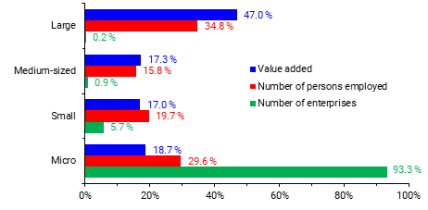

Share of large, medium, small and micro firms in value added, employment and number of enterprises. Data refers to EU27. Source: ICW, *SME Performance Review 2021.*<https://ec.europa.eu/growth/smes/sme-strategy/performance-review_en>

Perhaps most strikingly, SMEs are the biggest *net* job creators. According to the International Labour Office (2015, p. 9), young enterprises, especially young SMEs, “create a disproportionately high number of jobs”. The report refers to SMEs creating more jobs than warranted by looking at their share of employment. And not only do they create more jobs*, they also destroy fewer jobs.* SMEs are therefore strong ***net*** job creators. The report adds that,

“Although young enterprises respond more strongly to economic upturns or downturns than old enterprises, they remained net job creators during the Great Recession of 2007–09. Most of the job losses were caused by contractions of mature businesses” (ibid., p. 9)

The following figure is taken from that same report.

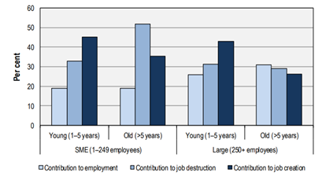

Employment, job creation and destruction by enterprise age and size. OECD sample (2001–2011). Source: International Labour Office (2015, p. 10, Fig. 2.6).

Also, “young enterprises are less likely to survive than older enterprises, but the surviving young enterprises tend to have higher employment growth rates.” (De Kok et al., 2011, p. 8). The second effect outweighs the first. Furthermore, fast-growing SMEs provide the bulk of job creation.[4]

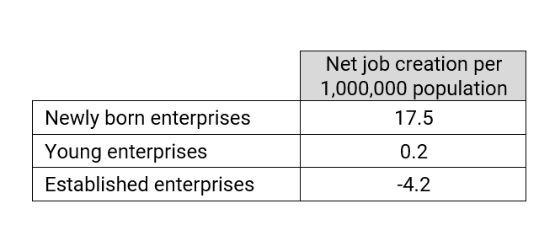

Net job creation 2004–2010 by age group of enterprises that survived. Source: De Kok et al. (2011, p. 8). Based on Amadeus/Orbis, Bureau Van Dijk.

## SMEs Depend on Banks

Getting external funding is not easy for SMEs. This is for various reasons. Unlike large firms, SMEs cannot access regulated capital markets at an affordable cost, for fees are much higher for small denomination issues (European Parliament, 2019, p. 2).[5] Being unable to access capital markets, SMEs turn to banks as their only alternative for external funding of substantial amounts (SMEs tend to borrow from family and friends, but the amounts tend to be smaller, naturally) (OECD, 2018, p. 10). But banks, like most lenders, typically ask for collateral to reduce the loss given default of the borrower (it is estimated that around 50–70% of loans to non-financial firms are collateralised), but unlike larger firms, SMEs often do not have good quality collateral to offer (Degryse, Karapetyan and Karmakar, 2019, p. 1; Beck et al., 2015). Banks prefer to deal with larger firms (OECD, 2018, p. 6; Brown and Lee, 2014, p. 9). To compensate for this, banks tend to charge SMEs higher interest rates (OECD, 2018, p. 8)[6] compared to large firms with better collateral or a longer credit history or a credit rating, and SME loan applications are more frequently rejected (European Commission, 2009).[7]

The next two figures tell this story visually using data for euro area banks and SMEs. As shown below, small firms (which are part of the SME sector) tend to be charged a higher interest rate compared to large firms, tend to cite access to finance as their most pressing problem more commonly, their loan applications get rejected more often, and when they get accepted, they tend to get everything they ask for less frequently.

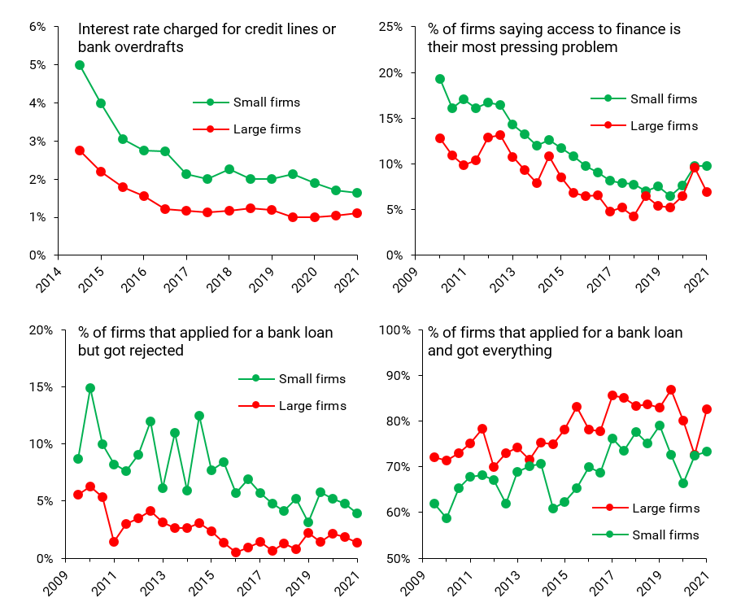

Source: ECB Statistical Data Warehouse, Survey on Access to Finance of Enterprises (SAFE).<https://sdw.ecb.europa.eu/browse.do?node=9138776>

Consistent with the above description, even though SMEs cite insufficient collateral, high interest rates and lack of availability of willing lenders among their reasons for not asking banks for borrowed money relative to larger firms, *fewer* SMEs of those that do not seek bank funding say they do so because they do not need it. This is shown in the next figure.

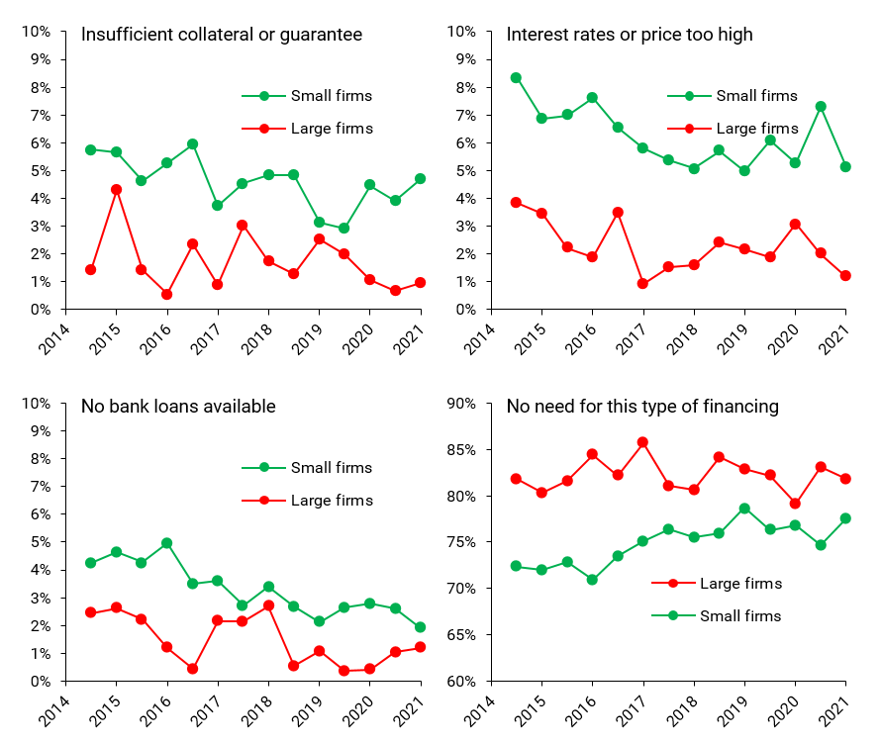

Most important reason why bank loans are not relevant. Source: ECB Statistical Data Warehouse, Survey on Access to Finance of Enterprises (SAFE).<https://sdw.ecb.europa.eu/browse.do?node=9138776>

The next figure paints the same picture. Despite the fact that SMEs are reliant on bank loans to a higher extent than larger firms, the unattractive terms at which banks *agree* to lend to them result in SMEs applying less for loans and therefore receiving less loans relative to larger firms. Many SMEs are known to be discouraged, and some of them never attempt to borrow from banks in the first place. Evidence from the US suggests that borrower discouragement is prevalent across SMEs (Levenson and Willard, 2000; Han et al., 2009), and younger and smaller firms are much more likely to be discouraged borrowers (Han et al., 2009).

To compensate for this, SMEs tend to rely more on bank overdrafts, credit card debt and, less commonly, on grants and subsidised loans, as in the recent Covid-19 crisis.

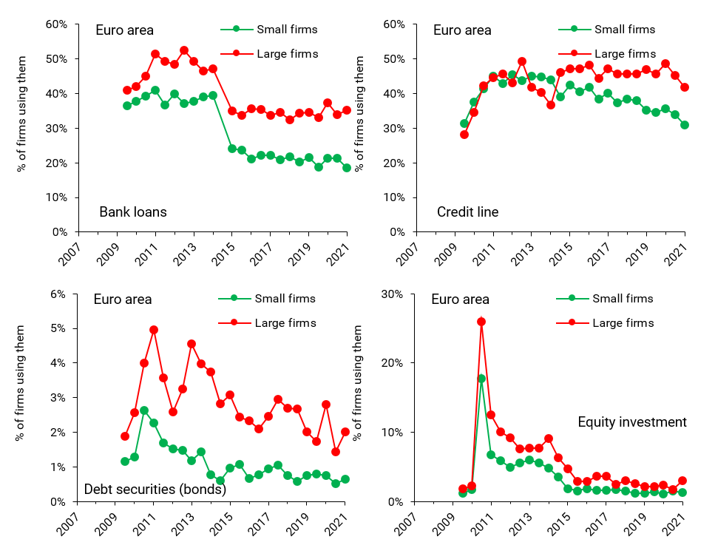

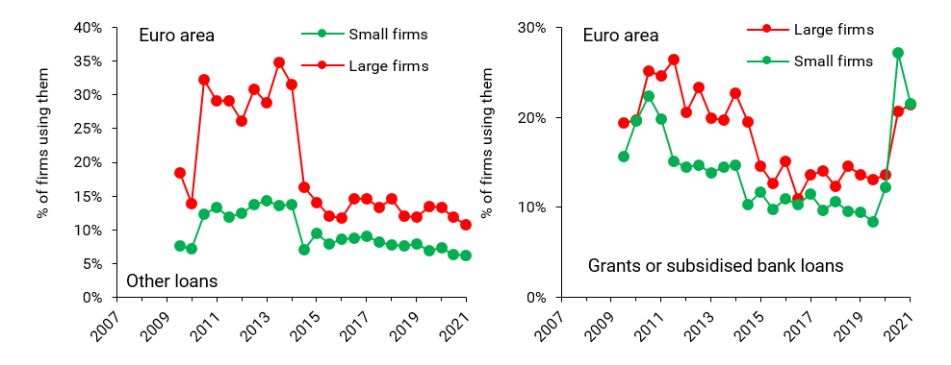

Sources of financing used. Source: ECB Statistical Data Warehouse, Survey on Access to Finance of Enterprises (SAFE).<https://sdw.ecb.europa.eu/browse.do?node=9138776>

The Covid-19 crisis showed quite presciently the extent to which SMEs are dependent on bank loans. When governments introduced loan guarantees, SMEs were the main beneficiaries and users, as shown below.

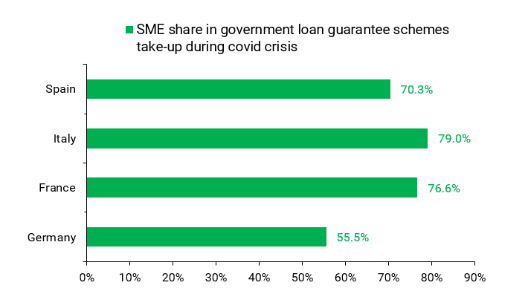

Source: ECB (2021), *Financial Stability Review,* May 2021.

All in all, these data tell us that *SMEs have a hard time accessing external funding*, they are heavily reliant on bank lending, and when their loan applications are accepted, the terms of the loan contract are generally less advantageous compared to larger borrowers.

## Large Banks Do Not Serve SMEs

There is a rule in banking: *big banks prefer to do big deals with big customers.* Thus, it is small banks which tend to extend small loans to small businesses, as shown by the work of **Prof. Richard Werner** (see graph below). Consequently, when small banks disappear (due to mergers, closure, etc.), SMEs find it harder to obtain funding from big banks, which prefer to deal with bigger customers.

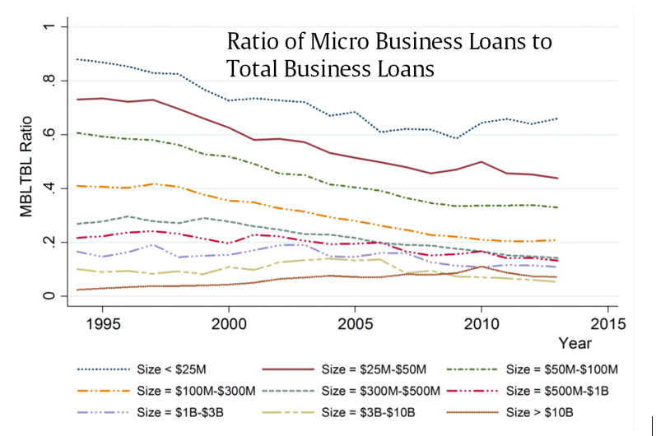

This graph illustrates the actual behaviour of bank lending to micro businesses over time for U.S banks. Each line represents the lending propensity of each of nine bank size groups over the period from 1994 to 2013. Source: Mkhaiber and Werner (2021).

The next figure uses data for Swiss banks to show the same pattern. Loans to companies with less than 10 employees in Switzerland account for a higher share of the balance sheet of smaller banks relative to that of bigger banks. The reverse is true with regards to loans to non-SMEs (i.e., firms with more than 250 employees).

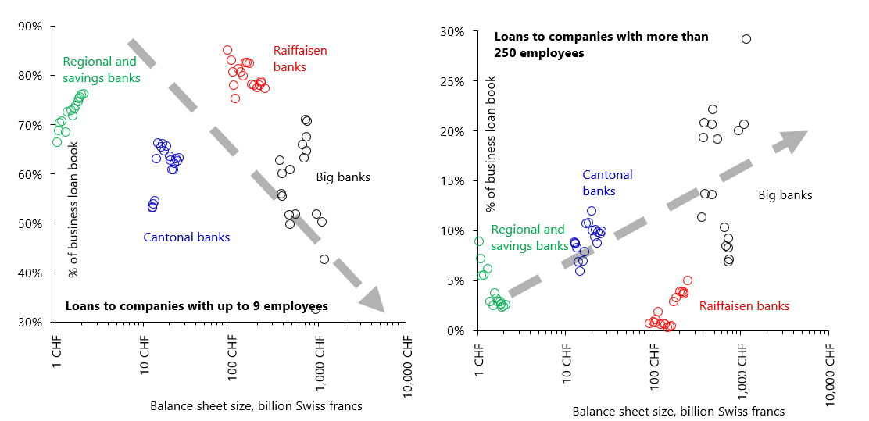

Vertical axis: share of loans to micro-companies (with less than 10 employees) in Switzerland as a percentage of the total balance sheet by type of bank. Data for banks resident in Switzerland. Horizontal axis: balance sheet of the banks. Source: Swiss National Bank.<https://data.snb.ch/en/topics>

The USA provides an interesting case. Since the mid-1980s, the number of community banks has fallen dramatically, from 15,661 in 1984 to 4,825 in 2019 (a staggering 69% drop in 35 years). As shown below, there is a clear correlation between the share of loans of “small” denomination (loans with principal < $100,000) in total loans and the community banks’ share in total commercial and industrial (C&I) loans, suggesting that *community banks are the primary lenders of small-denomination loans,* not surprisingly. Naturally, SMEs are the most likely borrowers of these loans. Incidentally, large-denomination loans (those with principal >$1,000,000) tend to be 3 times more volatile.

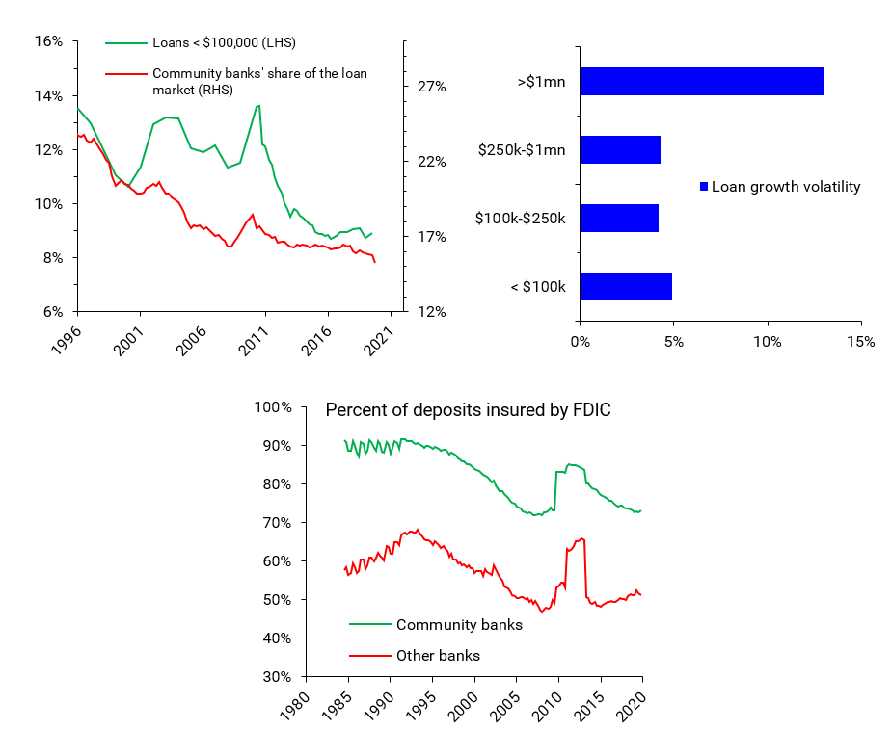

Market share of community banks in total bank lending in the US (green) and the share of commercial and industrial (C&I) loans of denominations below US$1MM in total C&I loans (blue). Source: FDIC

The following figures show some correlations of banking concentration and various variables of relevance related to SME borrowing. As can be seen, in a more concentrated banking system (measured as the share of the biggest banks in total assets), relative to bigger firms, SMEs tend to apply less for bank loans, their loan applications get rejected more often, and they get charged higher interest rates.

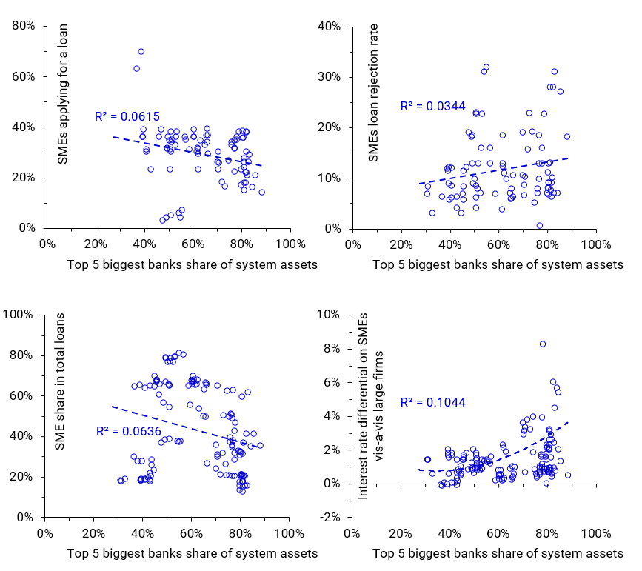

Data are for 15 OECD countries, 2007–2016 (source: OECD.Stat, *Financing SMEs and Entrepreneurs: An OECD Scoreboard*), and 45 countries, 2006–2017 (source: World Bank (2019), *Global Financial Development Database*). Complementary sources: BIS, SME Finance Forum.

What about that sub-sample of SMEs that is considered the most competitive, the so-called “*hidden champions*”, which are those SME firms that rank on the top-3 in terms of global market share in their market niches? The data here also support the view that small banks are critical for their success. The figure below shows that there is a considerable correlation between the number of banks and the number of hidden champions, both measured in per capita terms.

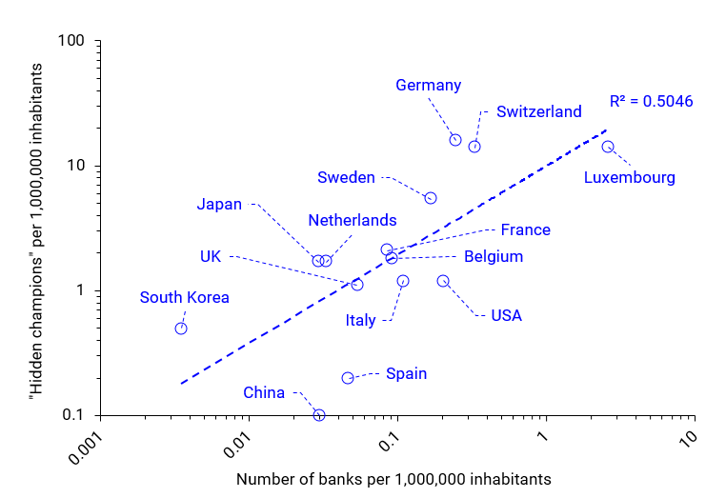

Data are for 2014. Source: Simon, Kucher & Partners; Bank of International Settlements.

The case of Germany is illuminating. As of 2014, it was the country with the highest number of hidden champions, both in absolute terms (1,300+) and per capita (16 per 1,000,000 residents). German export competitiveness is widely known. Less known is the fact that Germany is home to some 1,500+ banks (the highest number in Europe). Around 70% of these banks are locally-controlled, small, not-for-profit community banks.[8] These small banks lend to local SMEs, which account for a large bulk of German exports.

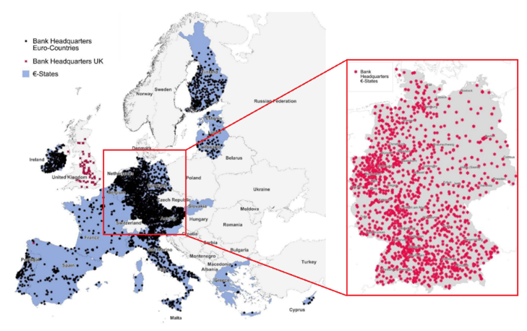

Gärtner and Fernandez-Montoto (2018)

The following figure compares the geography of German-based bank headquarters and German hidden champions. The similarities are striking.

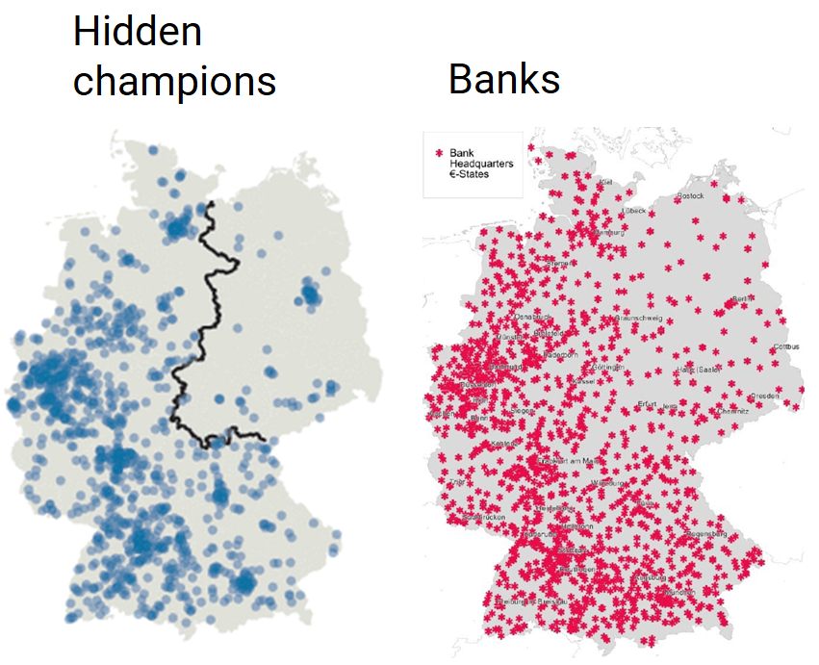

Left: The Economist (2019). Right: Gärtner and Fernandez-Montoto (2018)

**… and banking system concentration is increasing in most countries**

Sadly, banking systems across the world are only getting *more and more concentrated*. The following figure shows data for 28 EU countries. The various indicators of concentration (the share in total assets of the biggest 5 banks, the Herfindahl-Hirschman Index (HHI) for assets and credit) have consistently increased in the period of 1997-2017.[9]

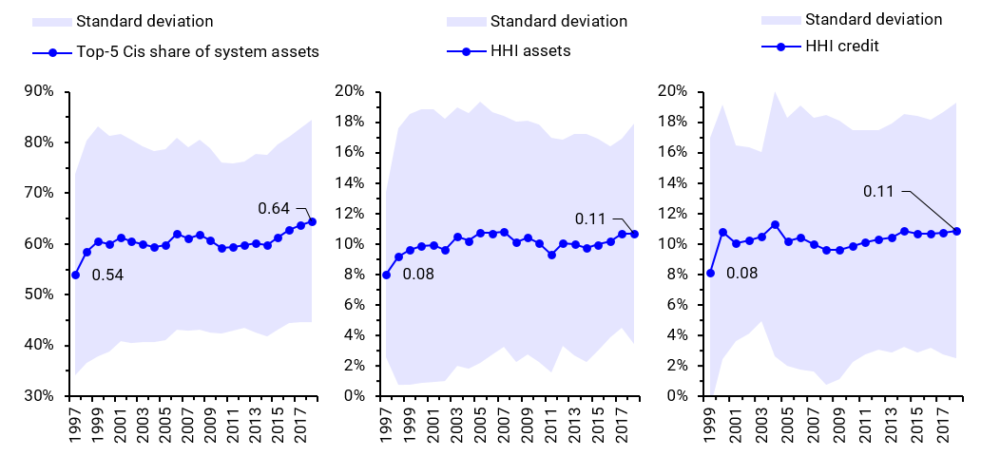

Left: Share of biggest 5 credit institutions in system assets. Middle: Herfindahl-Hirschman Index (HHI) for credit institution assets. Right: HHI for credit institutions’ credit. Data for 28 EU countries including the UK. Source: ECB Statistical Data Warehouse, Structural financial indicators.

This can be seen also by looking at the number of banks. With the exception of Ireland, the number of banks in European countries has registered a steady decline throughout the last two decades. The following figure shows the total number of credit institutions in the European Union. *If the trend continues, by mid-century there will be less than 100 banks left in the EU.*

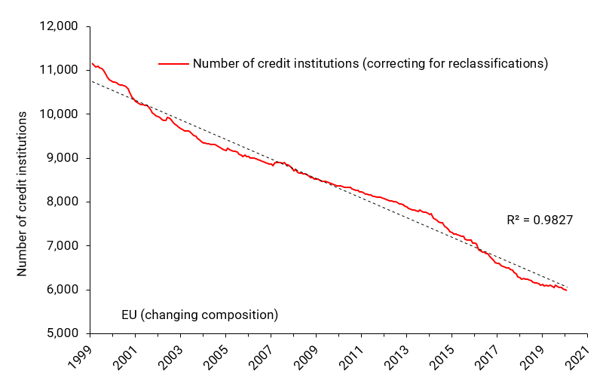

Source: ECB Statistical Data Warehouse, List of financial institutions,<https://sdw.ecb.europa.eu/browse.do?node=9691593>

The following figure shows data on the number of banks in absolute and per capita terms for a number of advanced countries in a shorter time span, 2005 to 2015. As can be seen, with the exception of Australia, Mexico and a few others, the number of banks has decreased across the board, sometimes dramatically as in the case of China.

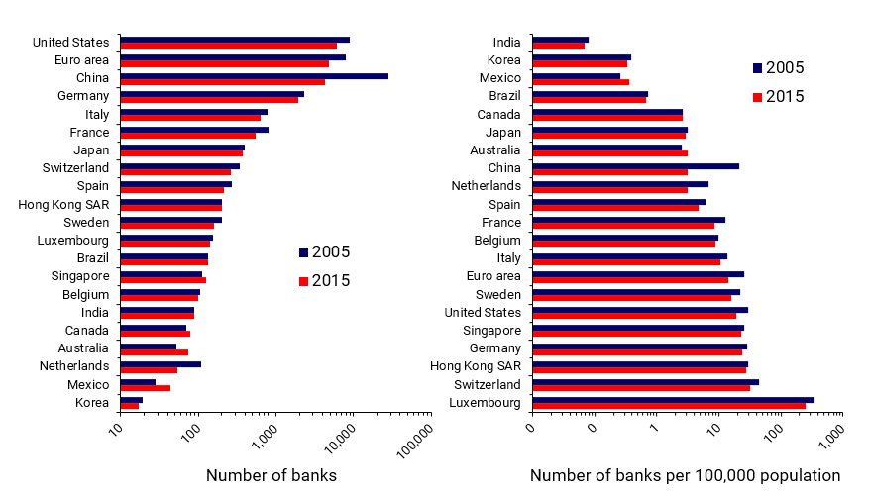

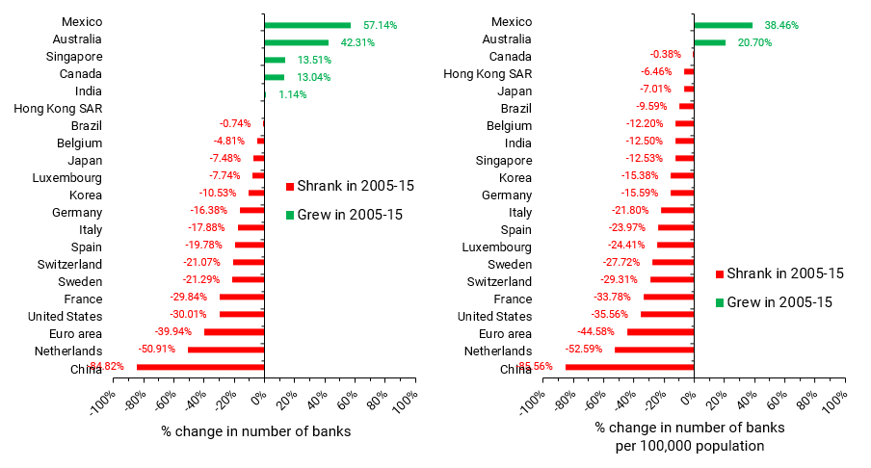

Source: ECB Statistical Data Warehouse, List of financial institutions,<https://sdw.ecb.europa.eu/browse.do?node=9691593>

Although there may be multifarious reasons for the decline, we can point to the relative disadvantage smaller banks have in terms of *compliance costs*. As shown below, smaller banks tend to lack the economies of scale of bigger banks, and compliance costs represent a higher percentage of their non-interest expenses (up to 4 times).

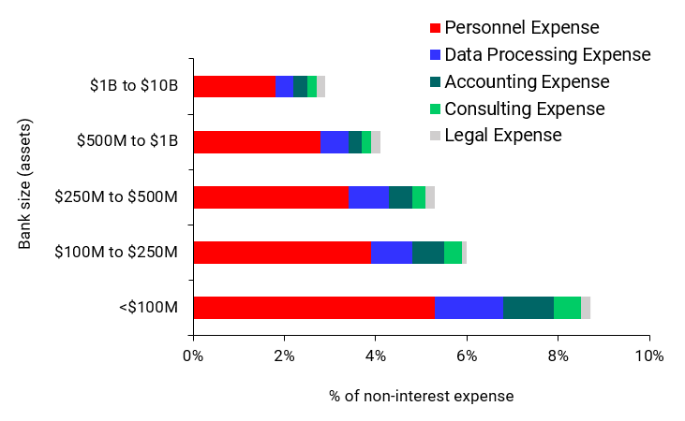

Sample consists of 469 U.S. banks. Source: Dahl and Meyer (2016)

Note that the data of the previous figure are for the USA, where there are a different set of regulations for small and big banks. In the EU, authorities mandate that *all* banks adhere to the same regulations (i.e., Basel III/IV, etc.), regardless of their size.

The following table shows the cost of compliance as a percentage of assets for a sample of 251 EU banks. An even more dramatic result emerges: *for smaller banks, compliance costs are on average 25 times that of large banks* (1.03% might not seem like a lot, but remember that banks have return-on-assets in the range of 0.1-0.4%).

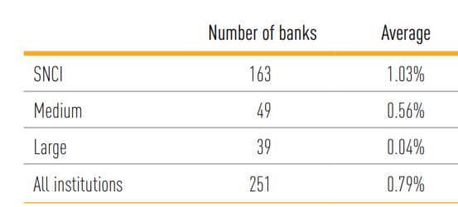

Compliance costs in percent of total assets (average across 2018-2020). SNCI stands for Small and Non-Complex Institutions. Source: EBA (2021, p. 72)

Sometimes in economic policy circles, this reduction in the number of banks is considered a positive development, and the argument that “there are too many banks” can sometimes be heard. This cannot possibly be true if we take a historical perspective. If we go back to the 1700s, we see that the number of banks today is *already* close to historical minima (more so in per capita terms), and one would have to go to the late-19th century in the case of the USA and Italy, and to the mid-18th century in the case of the UK, to find a comparable figure.

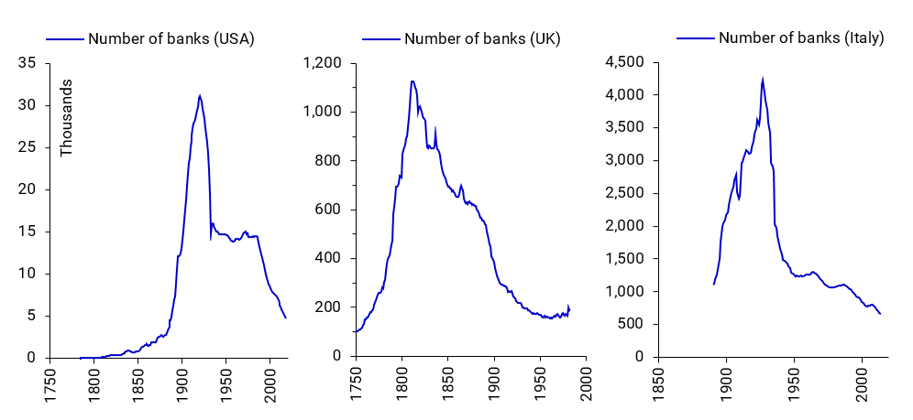

The number of banks in the USA, UK and Italy. Sources: Mitchie, Bank of England, British Bankers Association, Weber (2006), Fohlin and Jaremski (2019), FDIC.

## Large Banks Lend for the Wrong Reasons

Bank lending for speculative purposes creates banking crises and recessions, bank lending for consumption creates consumer price inflation, and bank lending for capital formation creates economic growth

For centuries, it was thought that for an economy to grow, the amount of money in circulation ought to increase proportionally. This was the famous “quantity theory of money”, also called the “equation of exchange”. This equation, linked together with the “real economy” (*Y*) (what we today call real Gross Domestic Product or GDP), the price level (*P),* with the amount of money (*M*), which circulated with certain velocity (*V*).

For a while, this relationship worked well empirically, and the data seemed to suggest the equation was valid, which meant that velocity *V* was relatively constant, and the link between money *M* and the real economy *Y* was understood: more money, more economic activity.

In the 1970s, however, the equation began to break down, and velocity *V* no longer seemed stable; it actually fell substantially during the 1970s through the 1980s across industrialised countries. As Charles Goodhart, a prominent UK monetary economist put it:

“The equation came apart at the seams during the course of the 1980s” (Goodhart, 1989).

In other words, the link between money and the economy was no longer a reliable one. The economics profession reacted by capitulation and dropped money altogether from virtually all economic models (the infamous DSGE models that failed to forecast the 2008 crisis) (Wieland V & Wolters M, 2012).

During the 1990s, a series of papers by Werner (1992, 1997) appeared that showed that the equation was still valid, it only had to be adapted to our modern banking system.

Werner performed two operations to the quantity equation:

* Replace money (*M)* with bank credit (*Cb*)
* Divide the money stream into two: money that goes into the real economy (*CRb*), like loans for SMEs, and money that goes into speculation and unproductive uses (*CFb*), like real estate and investment funds.

The replacement of money (*M)* by bank credit (*Cb*) can be done because, as several central banks and dozens of economists now recognise, *banks create money when they grant loans*. The Bank of England, for example, explains in a 2014 paper that:

“When banks make loans, they create additional deposits for those that have borrowed … Banks making loans and consumers repaying them are the most significant ways in which bank deposits are created and destroyed in the modern economy” (Bank of England, 2014)

More recently, the Bundesbank stated that:

“In fact, book money is created as a result of an accounting entry: when a bank grants a loan, it posts the associated credit entry for the customer as a sight deposit by the latter and therefore as a liability on the liability side of its own balance sheet. This refutes a popular misconception that banks act simply as intermediaries” (Bundesbank, 2017)

According to the UK’s most prominent monetary economist, Charles Goodhart, this new view “is now taking over as the consensus approach” (Goodhart, 2017).

In a landmark experiment, Richard Werner (2014a) performed an empirical test on a small German bank in lower Bavaria, the *Raiffeisenbank Wildenberg e.G*. The test consisted in borrowing €200,000 from the bank and recording all the internal transactions that the bank registered in its IT accounting system. The test showed without a doubt that the bank created the money when it extended the loan. No money was transferred from other accounts inside or outside the bank. The money was created “out of nothing”.

In other words, unlike non-bank firms, banks *create money when they lend to households, firms and governments.* They do so by crediting the borrower’s account, as a simple double-entry book-keeping exercise.

The next figure shows the structural difference between the mechanics of bank lending and non-bank lending.

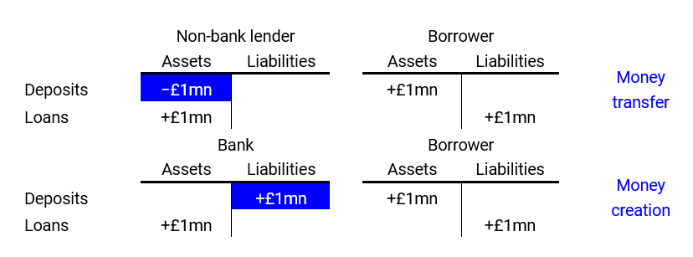

Mechanics of lending by non-banks (top) and banks (bottom).

Thus, the quantity theory of money can be turned into two separate equations:

*CbV = CRbVR + CFbVF*

*PQ = PRQR + PFQF*

The next step in Werner’s logic was to equate the first pair of variables and the second pair of variables, so that:

*CRbVR = PRQR = PRY*

With *VR = PRY / CRb constant*

And:

*CFbVF = PFQF = PFA*

With *VF = PFA / CFb constant*

Applying the chain rule for differences (that is, Δ(*ab*) = *a*Δ*b* + *b*Δ*a*. With *a* constant, Δ(*ab*) = *a*Δ*b*) which, when applied to stocks, represent flows:

Δ*PRY =* Δ*nGDP =* Δ*CRbVR*

Δ*PFA =* Δ*CFbVF*

Finally, using year-over-year relative growth rates:

Δ*nGDP / nGDP =* Δ*CRb/CRb* (1)

Δ*PFA / PFA =* Δ*CFb/CFb* (2)

The quantity theory of money turned into a new theory: *the quantity theory of disaggregated credit (QTDC).* It has two predictions:

* Equation (1): the economy grows if bank lending for the real economy grows
* Equation (2): asset bubbles are caused by non-productive bank lending

Since it was formulated in the 1990s by Werner, other scholars have put the theory to test with successful results.[10] Virtually all of the papers found that bank lending to the real economy, measured in various ways, was the only statistically significant variable explaining nominal GDP growth.

The next figure shows estimates by Werner (1997) for the Japanese economy during the 1980s and 1990s. The left panel shows the first prediction of the theory, namely, that nominal GDP growth ought to be caused by bank credit for GDP transactions. The right panel shows the second prediction: asset bubbles (in this case land prices) are caused by bank credit to real estate.

The econometric tests performed by Werner confirmed the predictions, but we can see by visual inspection that the theory is very plausible.

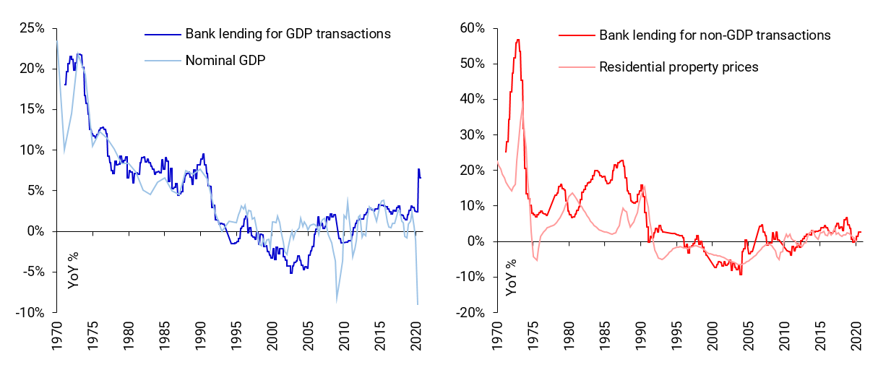

Source: Werner (1997), Bank of Japan.

The next two panels use data for the euro area.

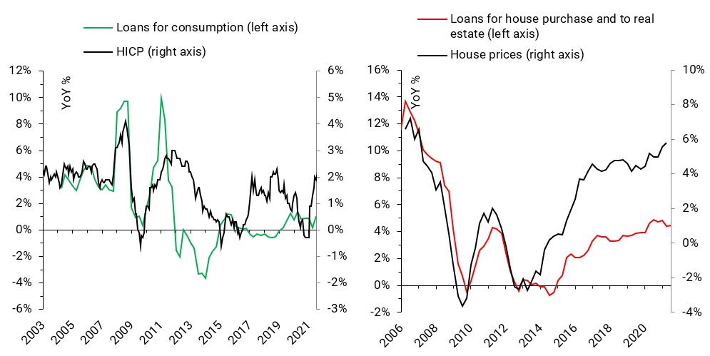

Left panel: bank loans for consumption and consumer price inflation, measured as the annual change in the Harmonised Index of Consumer Prices (HICP). Right panel: bank loans for house purchase and to real estate-related businesses, and house prices. Source: ECB Statistical Data Warehouse; author’s calculations.<https://sdw.ecb.europa.eu/>

In the area of banking and macroeconomics, Richard Werner’s quantity theory of credit stands as the empirically most successful theory. The theory has far-reaching implications:

1. **The economy can only grow if banks lend for activities that contribute to GDP**

This includes lending to firms that will invest (I) in machinery, R&D, staff training, acquisition of fixed assets, etc.; lending to governments (G) who will spend in paying civil servants and infrastructure projects, and lending to households for consumption (C).

GDP = C + I + G + NX

1. **Asset bubbles can be prevented**

This can be done by redirecting bank lending away from mortgages and lending to other financial institutions, to lending to non-financial firms.

1. **Only lending to the real economy is sustainable**

For every pound in new debt created by bank loans to the real economy, there is a one-pound increase in national income (GDP). Therefore, the debt is sustainable and can be serviced and repaid. GDP grows in tandem with debt, and debt-to-GDP levels stay constant.

Bank lending to non-GDP activities, on the other hand, increases debt but does not increase GDP. It leads to ever-higher debt-to-GDP ratios which create crises, recessions and debt overhangs that stifle growth. They also decrease house affordability and increase inequality through capital gains.[11]

1. **Lending for consumption can create inflation. Lending for investment in machinery, equipment, R&D, etc., is less inflationary**

If more money chases a fixed amount of goods and services, it is more likely that this will result in inflation than if lending is directed at investment, which will expand the productive capacity of the economy and thus increase demand as well as supply of goods and services.

1. **Small banks can have big effects**

Unlike non-bank financial intermediaries like investment funds, bank lending creates money, and if fed adequately to the economy (through GDP expenditures), it can make whole communities and regions grow in a sustainable way.

Furthermore, SMEs are the biggest employer in most countries, and they are the backbone of any economy. As mentioned, a dramatic case in point is provided by German SMEs: well-served by the thousands of small, not-for-profit community banks, these SMEs can access funding to grow. In fact, during the 2008-09 recession, unlike the big German banks, the small banks increased lending to their SME customers when they most needed it. Germany has the highest number of “hidden champions”, more than any other country in the world. These firms are world leaders in their niche markets in terms of market share, and they contribute substantially to Germany’s 8%-odd trade surplus.

From the perspective of the quantity theory of disaggregated credit, the composition of the loan book of European banks looks far from desirable. The next figure breaks down euro area bank lending into different sectors and according to whether the funds are used by borrowers for capital formation (e.g., machinery, R&D), consumption, or speculation (all non-GDP transactions, e.g., acquisition of financial assets, of existing real estate assets) (in the previous equations, capital formation and consumption are part of *CRb*, and speculation is part of *CFb*).

As can be seen, as of Q2 2021, only 27.85% of bank lending is directed at capital formation, 18.3% is directed at consumption, both of which contribute to economic growth, although only the former creates *real* (inflation-adjusted) GDP growth. Stunningly, 53.85% of bank loans are for speculative purposes, mainly the acquisition of existing houses which, as mentioned, translates into higher house prices but does not contribute to GDP growth.

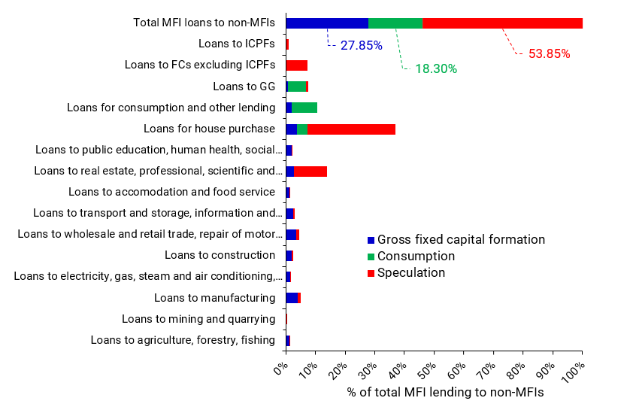

Source: ECB Statistical Data Warehouse.

Worse still, the share of speculative loans in total loans has only increased in the last 17 years.

## Concentrated Banking Speculates and Holds Less Capital

Finally, as shown in the figure below, there is some evidence that more concentrated banking systems go hand-in-hand with a higher share of mortgages in total bank loans, and a lower share of business loans. They also tend to hold more bonds (typically government bonds, which fund mostly consumption and to a lesser extent capital formation), have less capital, and are more profitable.

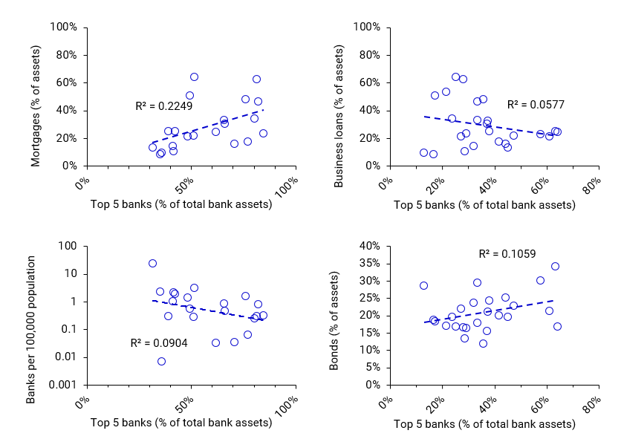

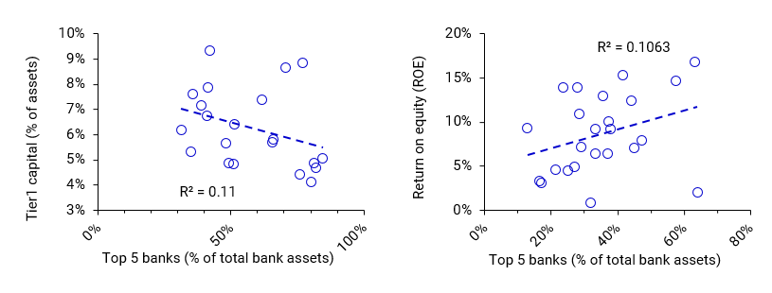

Data are for 2015. Source: BIS banking structure data.

## Summary of the Financial System

In particular for net job creation, it is evident that SMEs are crucial for any economy. Despite their heavy dependence on banks for their main source of external funding, SMEs are usually charged higher interest rates and struggle to access necessary finance from their banking provider.

Small businesses are subject to ever increasing stress as banking systems are universally becoming more concentrated with fewer banks operating. Empirical data shows that the remaining banks are becoming more speculative and increasing the share of mortgages on their balance sheets; this behaviour contributes little to economic prosperity and, in fact, engulfs economies in banking crises and deep recessions.

Community banks foster a more robust and resilient economy, and enable SMEs to thrive. Evidence shows that as the number of banks per capita increases, the number of successful SMEs or “hidden champions” per capita increases with them. Valhalla Network will democratise finance and create these healthy economies.

# Bibliography

Bank of England (2014), ‘Money creation in the modern economy’. By McLeay, M., A. Radia, and R. Thomas, Bank of England Quarterly Bulletin 2014 Q1

Beck, T., H. Degryse, R. de Haas and N. van Horen (2015), ‘When arm's-length is too far. Relationship banking over the business cycle’. Working Paper

Borio, C., L. Gambacorta, and B. Hofmann (2015), ‘The impact of monetary policy on bank profitability’. BIS Working Papers, No 514

Brown, Ross and Lee, Neil (2014) Funding issues confronting high growth SMEs in the UK.

Bundesbank (2017), ‘The role of banks, non-banks and the central bank in the money creation process’, Deutsche Bundesbank Monthly Report April 2017

Dahl, D., and A.P. Meyer (2016), ‘Scale Matters: Community Banks and Compliance Costs’, Federal Reserve Bank of St. Louis.

Degryse, H., A. Karapetyan and S. Karmakar (2019), ‘To ask or not to ask: bank capital requirements and loan collateralization’. Bank of England Staff Working Paper, No. 778, February 2019

De Kok, J., P. Vroonhof, W. Verhoeven, N. Timmermans, T. Kwaak, J. Snijders, and F. Westhof (2011), *Do SMEs create more and better jobs?* EIM Business & Policy Research, November 2011

EBA (2021), *Study of the cost of compliance with supervisory reporting requirements,* European Banking Authority.

ECB (2021), *Financial Stability Review,* May 2021.

European Commission (2009), *Survey on the access to finance of enterprises (SAFE) - summary (2009)*

European Parliament (2019), *Enabling SMEs’ access to capital markets*. Briefing, European Parliamentary Research Service

FCA (2018), *Strategic review of retail banking business models*

Goodhart, C.A.E (1989), Money, Information and Uncertainty, 2nd ed., The MIT Press

Goodhart, C.A.E. (2017), ‘The determination of the money supply: Flexibility versus control’. Proceedings of the Money, Macroeconomics and Finance Research Group, 2016, Vol. 85, Issue S1, pp. 33-56, September 2017

Han, L., Fraser, S., and Storey, D. J. (2009). “Are good or bad borrowers discouraged from applying for loans? Evidence from US small business credit markets”. *Journal of Banking & Finance*, 33(2), 415-424

International Labour Office (2015), *Small and medium-sized enterprises and decent and productive employment creation,* Report IV.

Levenson, A., and K. Willard (2000), “Do firms get the financing they want? Measuring credit rationing experience by small businesses in the US”. *Small Business Economics*, 14

Mkhaiber A., and Werner R.A. (2021), “Funding of small firms: Are big banks less helpful and has the crisis changed this?”. ScienceDirect.

OECD (1997), *Small businesses, job creation and growth: Facts, obstacles and best practices*

OECD (2018), *Enhancing SME access to diversified financing instruments,* Discussion paper, SME Ministerial Conference, 22-23 February 2018, Mexico City.

The Economist (2019), ‘Germans still don’t agree on what reunification meant’

Werner, R.A. (1997), ‘Towards a new monetary paradigm: A quantity theorem of disaggregated credit, with evidence from Japan’, Kredit und Kapital, Duncker and Humblot, Berlin, Vol. 30, no. 2, July, pp. 276−309

Werner, R.A. (2014a), ‘Can banks individually create money out of nothing? — The theories and the empirical evidence’. International Review of Financial Analysis 36 (2014) 1–19

Werner, R.A. (2014b), ‘How do banks create money, and why can other firms not do the same? An explanation for the coexistence of lending and deposit-taking’. International Review of Financial Analysis 36 (2014) 71–77

Werner, R.A. (2015), ‘A lost century in economics: Three theories of banking and the conclusive evidence’. International Review of Financial Analysis

Wieland V., and Wolters M (2012), “Macroeconomic model comparisons and forecast competitions”. *VoxEU*

1. 3Y average pre-tax ROE for major banks, small retail banks, building societies, and specialised lenders is 28%, 6%, 11%, and 26%, respectively. (FCA Strategic Review, 2018)
2. For example, the Bank of England recommends a stress test for non-systemic banks where interest rates drop to -0.1%.
3. Forecasted dividends paid to the DAO only relate to the Phase 1 bank that the DAO will own and does not include any of the dividends coming from the Phase 2 network of community banks.
4. Enterprises mostly start as micro or small enterprises but might grow to become large enterprises. Few start-ups (2–9 per cent) grow above ten employees, but they make a substantial contribution to job creation, ranging from 19 to 54 percent. It is ultimately only a few enterprises that grow to become larger enterprises and generate most of the new jobs. These high-growth enterprises are often referred to as transformational entrepreneurs, graduate enterprises or gazelles, and they create vibrant businesses with jobs and income for others, beyond the scope of an individual’s subsistence needs. In contrast, subsistence entrepreneurs usually do not grow, but provide income and employment for the owner of the micro-enterprise and his or her family (International Labour Office, 2015, p. 10).
5. In the EU, companies wishing to raise capital on public markets through the issuance of shares or bonds have a choice between two broad categories of venues: regulated markets and multilateral trading facilities. Even though both categories are open to companies of all types and sizes, regulated markets have compliance requirements that render listing costlier and cumbersome for smaller firms (European Parliament, 2019, p. 2).
6. In the OECD countries, in 2008, the median interest rate charged to SMEs was 15.5% higher than the rate charged to large enterprises, whereas in 2016, that percentage had more than doubled, standing at 32.7% (OECD, 2018, p. 8).
7. In 2009, for instance, only 5.2% of loan applications were rejected among large firms, that share was double for small firms and even three times as large among micro-businesses (European Commission, 2009)
8. See<https://foe.scot/wp-content/uploads/2012/05/Edinburgh-Werner-Case-for-Local-Banks-2012.pdf>
9. The Herfindahl-Hirschman Index (HHI) is a common measure of market concentration and is used to determine market competitiveness. The higher HHI, the higher the concentration.
10. The QTDC was tested in Japan by Werner (1992, 1993, 1994, 1997), it was later applied to the Czech Republic (Bezemer and Werner, 2009), the UK (Lyonnet and Werner, 2012; Ryan-Collins, Werner and Castle, 2016), Spain (Werner, 2014c; Bermejo-Carbonell and Werner, 2018), Germany (Kusin and Schobert, 2014), and Japan later again (Werner, 2005, 2012; Voutsinas and Werner, 2011b).
11. It is quite well-established that house prices can be explained by: (i) on the demand side, the amount of real estate loans and household mortgages (Anundsen and Jansen, 2013, p. 6, Tables 1 and 2; Werner, 1997), and (ii) on the supply side, the elasticity of supply of housing by the construction sector (ESRB, 2015, pp. 31–32; Gao, Sockin and Xiong, 2015, p. 1; Gyourko, 2009, p. 11), which in turn is influenced, among other things, by regulatory supply constraints, city-level population, population density, and geographic constraints like steep topography (Glaeser, Gyourko and Saiz, 2008, pp. 36–37; Oikarinen and Valtonen, 2014).